

**Excel Assignment - 6**

1. **What are the various elements of the Excel interface? Describe how they're used.**

**Answer:** There are many things appears on the excel interface like On the very top center name of the workbook and or left side there is a option to save the workbook and on right corner options to minimize, close etc. below that different tabs were there like Home, insert, review etc. from that we can access all the functions and commands of excel through the ribbons and groups present in them, then just below that Name box and beside it formula bar present and beneath row number and column name were present and cells were there at the down side one bar is showing different sheet’s and from there we can add sheet delete or copy.

1. **Write down the various applications of Excel in the industry.**

**Answer:** Excel is widely used in industry some of its application are data analysis, creating tables, storing data in tabular form, creating charts, reporting and visualization, data entry etc.

1. **On the ribbon, make a new tab. Add some different groups, insert commands in the groups and name them according to their commands added. Copy and paste the screenshot of the steps you followed.**

**Answer :** 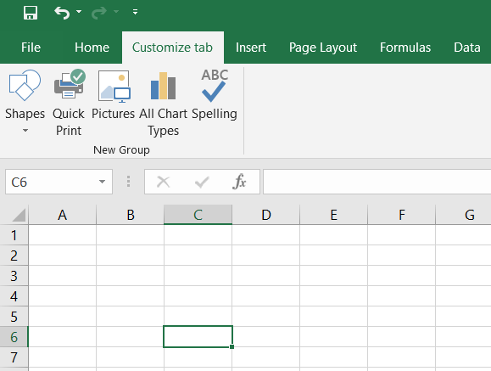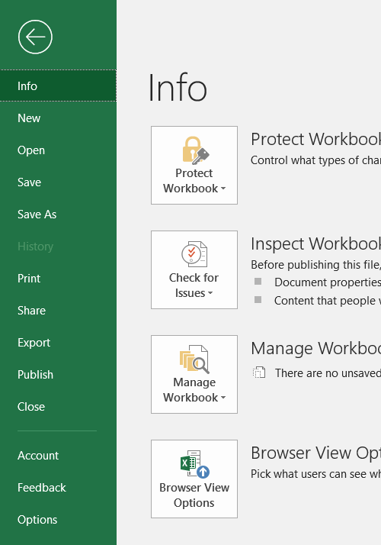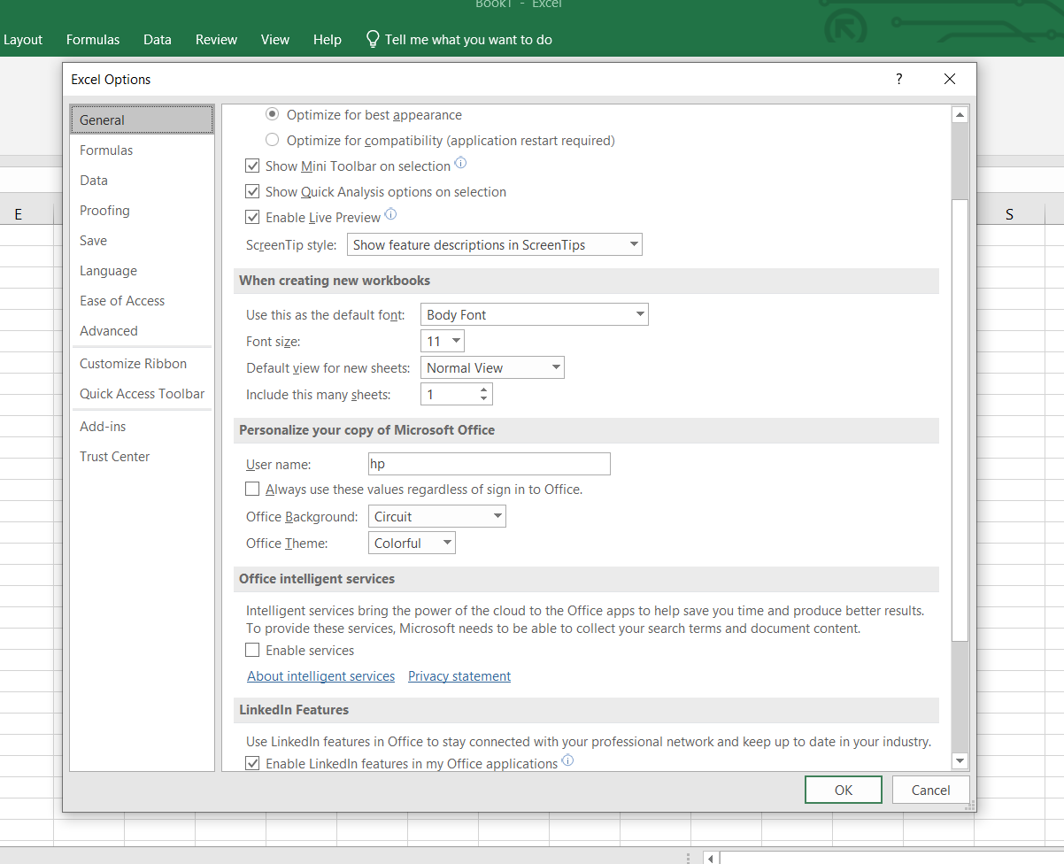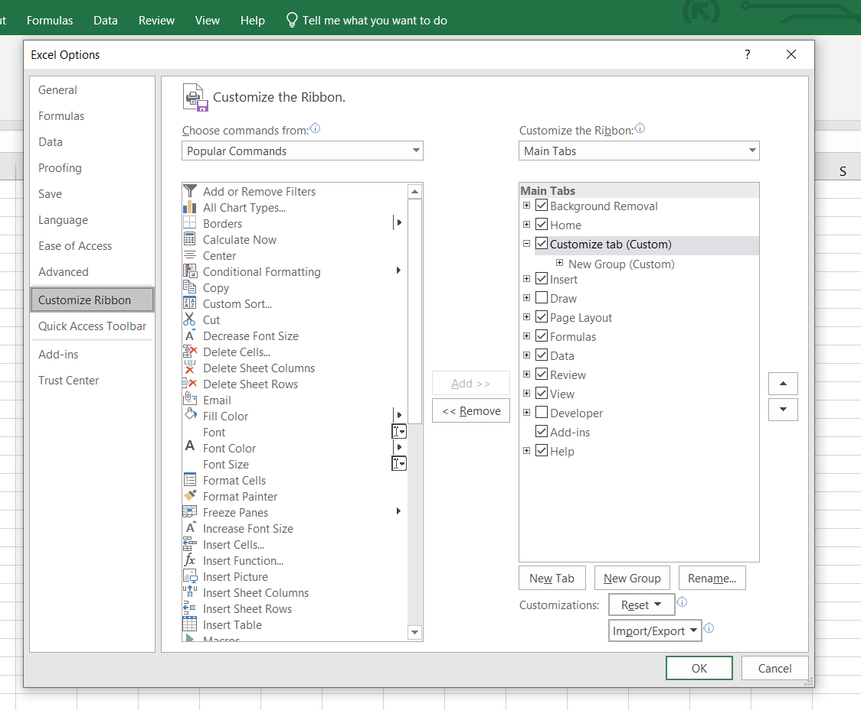

Step 1 – Click on Files

Step 2 - Click on Options

Step 3 – Click on Customize Ribbons

Step 4 – Click on New Tab

Step 5 – Click on New Group

Step 6 – Edit features from left table to the right and click on OK.

1. **Make a list of different shortcut keys that are only connected to formatting with their functions.**

**Answer -**

(Ctrl + Shift + -) – Remove all the borders from the selected cell or table.

(Alt + ‘) – Opens Style tab and form there we can access format

(Ctrl + B) – Applies or remove bold on the selection

(Ctrl + I) – Applies or remove Italics on the selection

(Ctrl + U) – Applies or remove Underline on the selection

(Alt + H,A,C) – Aligns the selection in center

(Alt + H,B,S) – Adds a thin border on all sides of the selection

(Ctrl + 5) – Applies Strike format

1. **What distinguishes Excel from other analytical tools?**

**Answer** – Excel is very easy to understand even for beginner level we can easily analyze data and can make charts and reports with some basic knowledge so excel is that much easy if we can go to advance level it has many features and options which are self-explanatory, when comparing excel with other analytical tools is excel is easily available on Microsoft powered PC’s and it is easily available online, No need to install it which is a tedious process for many analytical tools.

1. **Create a table and add a custom header and footer to your table.**

**Answer -**



      
      
      

